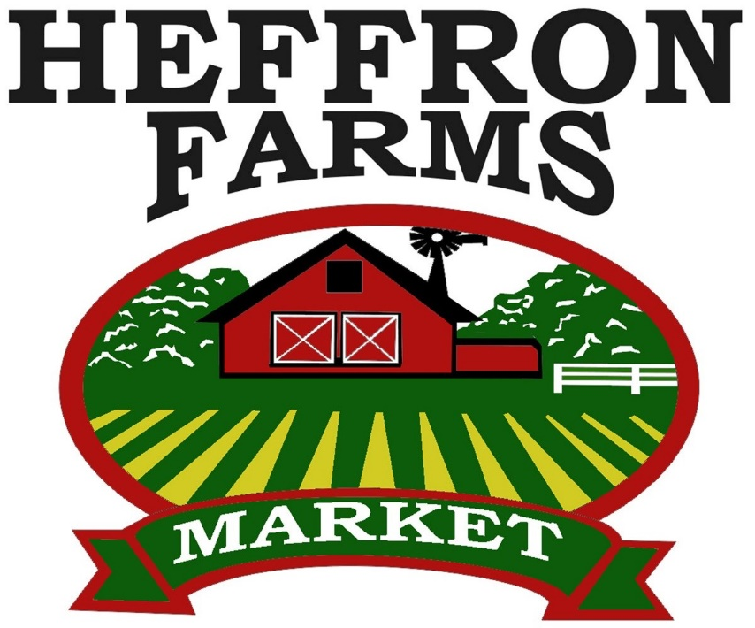

**BEEF, CHICKEN,**

**PORK, TURKEY**

**SALE**